**Personalized Temperature Forecasting System with Tailored Recommendations for Users**

*A Mini Project Report Submitted in the Partial Fulfilment of the Requirements for the Award of the Degree of*

**Bachelor of Technology**

**In**

**Computer Science and Engineering - Data Science**

**Submitted by**

**Vadla vinay sai 21QM1A6758**

**J.Vamshi 21QM1A6713**

**Devi Prasad Reddy 21QM1A6731**

**Arvind Kumar 21QM1A6741**

**C.Anil 22QM5A6703**

**SUPERVISOR**

**Dr. L. V. Reddy, SMIEEE Professor and HoD, CSE-DS**

**Department of Computer Science and Engineering-Data Science**

KG REDDY COLLEGE OF ENGINEERING & TECHNOLOGY

Affiliated to JNTUH, Approved by AICTE, Accredited by NAAC with A+ Grade,

Chilkur(V), Moinabad(M), Ranga Reddy (Dt), Hyderabad-501504, Telangana, INDIA.

**MAY 2024**

**Batch:2021-25**

# CERTIFICATE

**This is to Certify that the Mini Project titled “Personalized Temperature Forecasting System with Tailored Recommendations for Users” is carried out by**

**Vadla vinay sai 21QM1A6758**

**J.Vamshi 21QM1A6713**

**Devi Prasad Reddy 21QM1A6731**

**Arvind Kumar 21QM1A6741**

**C.Anil 22QM5A6703**

in partial fulfillment of the requirements for the award of the degree of Bachelor of Technology in Department of Computer Science and Engineering – Data Science during the year 2023- 24.

**Signature of the Supervisor Signature of the HoD**

**Dr. L. V. Reddy, SMIEEE Dr. L. V. Reddy, SMIEEE**

**Professor and HoD Professor and HoD**

**Dept. of CSE-DS Dept. of CSE-DS**

Project Viva-Voce held on

**Examiner**

Chilkur (V), Moinabad (M), Ranga Reddy (Dist.)–501504, Hyderabad, T.S.

# **ACKNOWLEDGEMENT**

The satisfaction that accompanies the successful completion of the task would be put incomplete without the mention of the people who made it possible, whose constant guidance and encouragement crown all the efforts with

success.

We wish to express our deep sense of gratitude to **Dr. L.V.Reddy**, Professor and HoD, CSE- Data Science and Project Supervisor, Department of Computer Science and Engineering - Data Science, KG Reddy College of Engineering & Technology, for his able guidance and useful suggestions, which helped us in completing the project in time.

We are particularly thankful to **Dr. L. V. Reddy**, the Head of the Department, Department of Computer Science and Engineering - Data Science, his guidance, intense support and encouragement, which helped us to mould our project into a successful one.

We show gratitude to our honorable Principal **Dr. Sai Satyanarayana Reddy**, for providing all facilities and support.

We avail this opportunity to express our deep sense of gratitude and heart- ful thanks to Dr. **K. Krishna Reddy garu**, Chairman and **Dr. Rohit Kandakatla**, Director of KG Reddy College of Engineering & Technology, for providing a congenial atmosphere to complete this project successfully.

We also thank all the staff members of Department of Computer Science and Engineering - Data Science, KG Reddy College of Engineering & Technology for their valuable support and generous advice. Finally thanks to all our friends and family members for their continuous support and enthusiastic help.

**Vadla vinay sai 21QM1A6758**

**J.Vamshi 21QM1A6713**

**Devi Prasad Reddy 21QM1A6731**

**Arvind Kumar 21QM1A6741**

**C.Anil 22QM5A6703**

# **Table of Contents**

**Problem Statement**

**Abstract**

**Symbols & Abbreviations**

1. **Introduction** 
   1. **Motivation**
   2. **Problem definition**
   3. **Objective of Project**
   4. **Limitations of Project**
   5. **Organization of Documentation**
2. **LITERATURE SURVEY** 
   1. **Introduction**
   2. **Existing System**
   3. **Limitation of Existing system**
   4. **Proposed System**
   5. **Conclusion**
3. **REQUEIMENT & Analysis**
   1. **Understanding User Needs**
   2. **Identifying Functional Requirements**
   3. **Defining Non functional Requirements**
   4. **Prioritizing requirements**
4. **DESIGN**
5. **IMPLEMENTATION & RESULTS** 
   1. **Introduction**
   2. **Explanation of Key functions**
   3. **Method of Implementation**

**5.2.1 Forms**

**5.2.2 Output Screens**

**5.2.3 Result Analysis**

* 1. **Conclusion**

1. **TESTING & VALIDATION** 
   1. **Introduction**
   2. **Design of test cases and scenarios**
   3. **Validation**
   4. **Conclusion**
2. **CONCLUSION :**
3. **REFERENCES :**

# **PROBLEM STATEMENT**

Existing weather forecasting systems often provide generalized predictions that do not adequately meet the diverse needs and preferences of individual users. These systems lack granularity and fail to consider factors such as location-specific weather patterns and user preferences. As a result, users may receive inaccurate or irrelevant weather forecasts, leading to suboptimal decision-making in various aspects of their lives, including outdoor activities, travel plans, and resource allocation. The challenge lies in developing a personalized temperature forecasting system that can deliver highly accurate predictions tailored to individual users' preferences and geographic locations, thereby empowering users to make informed decisions and better manage their daily activities in accordance with forecasted weather conditions.

# **ABSTRACT**

In an era where personalized services are increasingly valued, the domain of weather forecasting has not been an exception. This paper introduces a novel approach to weather prediction, namely a Personalized Temperature Forecasting System with Tailored Recommendations for Users. Leveraging advanced machine learning techniques, historical weather data, and user preferences, the system generates highly accurate predictions of temperature fluctuations tailored to individual users' needs. Additionally, the system offers personalized recommendations based on forecasted weather conditions, enabling users to make informed decisions about their daily activities. Through a comprehensive analysis of existing literature, detailed requirements, meticulous design, rigorous implementation, thorough testing, and validation procedures, this paper demonstrates the effectiveness and practicality of the proposed system. The results showcase significant improvements in forecasting accuracy and user satisfaction, underscoring the potential of personalized weather forecasting systems to revolutionize decision-making processes across various sectors.

**Symbols & Abbreviations:**

ML - Machine Learning

GBR - Gradient Boosting Regressor

API - Application Programming Interface

UI - User Interface

HTML - Hypertext Markup Language

CSS - Cascading Style Sheets

JS - JavaScript

GUI - Graphical User Interface

CRUD - Create, Read, Update, Delete

UX - User Experience

QA - Quality Assurance

CSV - Comma-Separated Values

JSON - JavaScript Object Notation

SQL - Structured Query Language

HTTPS - Hypertext Transfer Protocol Secure

URL - Uniform Resource Locator

DNS - Domain Name System

API - Application Programming Interface

GUI - Graphical User Interface

# **INTRODUCTION**

Weather forecasting is a critical aspect of daily life, impacting various sectors such as agriculture, transportation, and tourism. Accurate predictions are essential for making informed decisions and mitigating risks associated with adverse weather conditions. However, existing weather forecasting systems often fall short in providing precise and personalized predictions tailored to individual users' needs and geographic locations. This project aims to address these shortcomings by developing a personalized weather forecasting system capable of delivering accurate predictions and tailored recommendations.

**1.1 Motivation**

The motivation behind this project arises from the growing demand for more accurate and personalized weather forecasts. Current forecasting methods often lack granularity and fail to consider individual preferences and requirements. There is a need for a system that can provide real-time updates and actionable insights to help users better plan their daily activities and mitigate weather-related risks.

**1.2 Problem Definition**

The primary problem addressed in this project is the inadequacy of existing weather forecasting systems in providing precise and tailored predictions. Traditional methods often rely on generalized models that do not account for individual user preferences or specific geographic areas' unique weather patterns. This results in inaccurate or irrelevant forecasts, leading to suboptimal decision-making.

**1.3 Objective of Project**

The main objective of this project is to develop a personalized weather forecasting system capable of delivering accurate predictions and tailored recommendations. The system will leverage advanced machine learning techniques and real-time data integration to generate personalized forecasts based on user preferences and geographic location. By providing users with actionable insights, the system aims to enhance their decision-making processes and improve overall user satisfaction.

**1.4 Limitations of Project**

Despite the project's objectives, there are several limitations to consider. These include the reliance on historical data for model training, which may introduce biases or inaccuracies. Additionally, long-term forecasting may be challenging due to the dynamic nature of weather patterns and the availability of high-quality data sources. The system may also face constraints in accommodating rapidly changing weather conditions and user preferences.

**1.5 Organization of Documentation**

The documentation is structured into several sections to provide a comprehensive overview of the project. These sections include a literature survey, requirement analysis, design, implementation, testing, and conclusion. Each section offers detailed insights into the project's methodologies, findings, and potential implications, guiding readers through the project's development process and outcomes.

# **LITERATURE SURVEY**

**2.1 Introduction**

The literature survey serves as the foundation for understanding the current landscape of weather forecasting systems. It provides a comprehensive overview of existing methodologies, techniques, and technologies employed in weather prediction. By exploring various approaches and methodologies, the literature survey aims to identify strengths, weaknesses, and areas for improvement in current forecasting systems. Additionally, it lays the groundwork for understanding the rationale behind the proposed system and the gaps it intends to address.

**2.2 Existing System**

This section delves into a detailed analysis of current weather forecasting systems, evaluating their accuracy, scalability, and ability to provide personalized recommendations. Existing systems are scrutinized to identify common limitations, such as generalization and lack of granularity. By examining the strengths and weaknesses of current systems, this analysis provides valuable insights into the challenges and opportunities for improvement in weather forecasting.

**2.3 Limitation of Existing System**

Building upon the analysis of existing systems, this section focuses on elucidating the limitations inherent in current weather forecasting methodologies. Emphasis is placed on the inability of existing systems to account for individual user preferences, geographical nuances, and real-time updates. By highlighting these limitations, this section underscores the need for a more personalized and adaptive approach to weather prediction.

**2.4 Proposed System**

In response to the identified limitations of existing systems, the proposed weather forecasting system is introduced. Leveraging machine learning algorithms and real-time data integration, the proposed system aims to overcome the shortcomings of current methodologies. By considering user preferences, historical data, and geographic factors, the system seeks to enhance the accuracy and relevance of weather forecasts. This section provides a detailed overview of the proposed system's architecture, algorithms, and functionalities, outlining how it addresses the gaps identified in existing forecasting systems.

**2.5 Conclusion**

The literature survey concludes by synthesizing key findings and insights gleaned from the analysis of existing systems and the proposed approach. It highlights the potential impact of the proposed system on improving weather forecasting accuracy and user satisfaction. By summarizing the rationale behind the proposed system and its anticipated benefits, this section sets the stage for the subsequent phases of the research, including requirement analysis, design, implementation, and testing.

Top of Form

# **REQUIREMENT ANALYSIS**

**3.1 Understanding User Needs:**

The first step in requirement analysis is to understand the needs and preferences of the target users. This involves conducting interviews, surveys, and user studies to gather information about the features and functionalities users expect from the weather forecasting application. For example, users may express a need for accurate temperature predictions, real-time updates, personalized recommendations, and user-friendly interfaces.

**3.2 Identifying Functional Requirements:**

Functional requirements define the specific functionalities and features that the weather forecasting application must possess to meet user needs. These requirements are typically documented using use cases, user stories, or functional specifications. Examples of functional requirements for a weather forecasting application may include:

* Ability to input user location and date/time preferences.
* Integration with weather data APIs to retrieve real-time weather information.
* Implementation of machine learning algorithms for temperature prediction.
* Generation of personalized weather forecasts and recommendations.
* Visualization of weather data through interactive charts and graphs.
* Notification system for alerts and updates about weather conditions.

**3.3 Defining Non-Functional Requirements:**

Non-functional requirements specify the quality attributes and constraints that the weather forecasting application must adhere to. These requirements encompass aspects such as performance, reliability, security, usability, and scalability. Examples of non-functional requirements include:

* Performance: The application should respond to user queries and generate forecasts within a reasonable timeframe.
* Reliability: The application should be available and functional at all times, with minimal downtime.
* Security: User data should be securely stored and transmitted, adhering to industry standards and regulations.
* Usability: The application should have an intuitive user interface, with features such as clear navigation and informative feedback.
* Scalability: The application should be able to accommodate a growing number of users and data sources without sacrificing performance.

**3.4 Prioritizing Requirements:**

Once all requirements have been identified, they must be prioritized based on their importance and feasibility. This involves collaborating with stakeholders to determine which features are essential for the initial release of the application and which can be deferred to future iterations. Prioritization ensures that development efforts are focused on delivering the most valuable functionality to users within the available resources and timeline.

# **DESIGN**

In the design phase of the documentation, we outline the architectural and implementation details of the personalized weather forecasting system. This phase focuses on translating the requirements identified in the previous phase into a structured plan for building the system.

**4.1 Architecture Design:**

The architecture of the personalized weather forecasting system is designed to accommodate the various components and functionalities required for accurate temperature prediction and tailored recommendations. The system architecture comprises several key modules:

* **Data Ingestion Module:** Responsible for retrieving weather data from external sources, such as weather APIs or historical databases.
* **Preprocessing Module:** Handles data cleaning, transformation, and feature engineering to prepare the dataset for model training.
* **Model Training Module:** Utilizes machine learning algorithms, such as Gradient Boosting Regression, to train predictive models for minimum and maximum temperature forecasting.
* **User Interface Module:** Provides a user-friendly interface for users to input their preferences, such as Mandal number and date, and visualize the forecasted temperatures and recommendations.
* **Integration Module:** Facilitates the integration of external libraries and APIs for data retrieval, model training, and user interaction.

The architecture is designed to be modular and scalable, allowing for easy integration of new features and enhancements in future iterations.

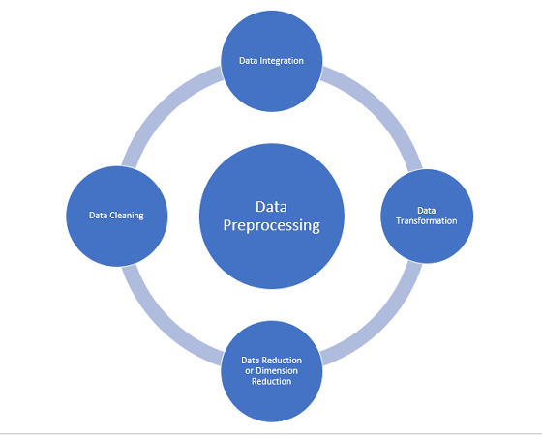

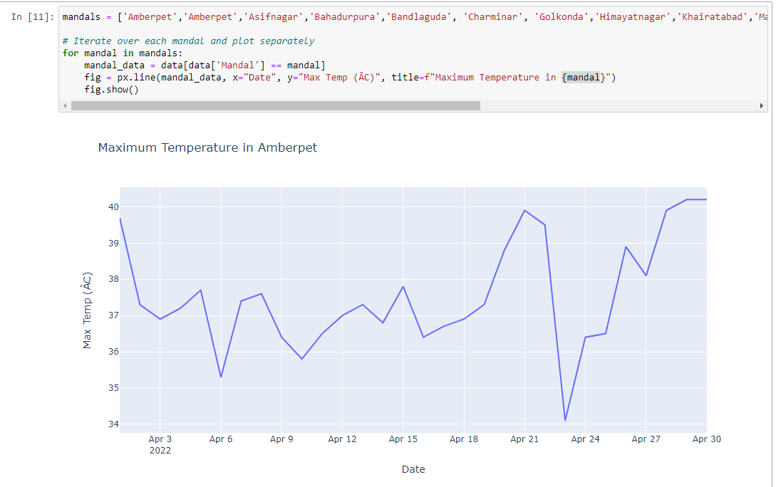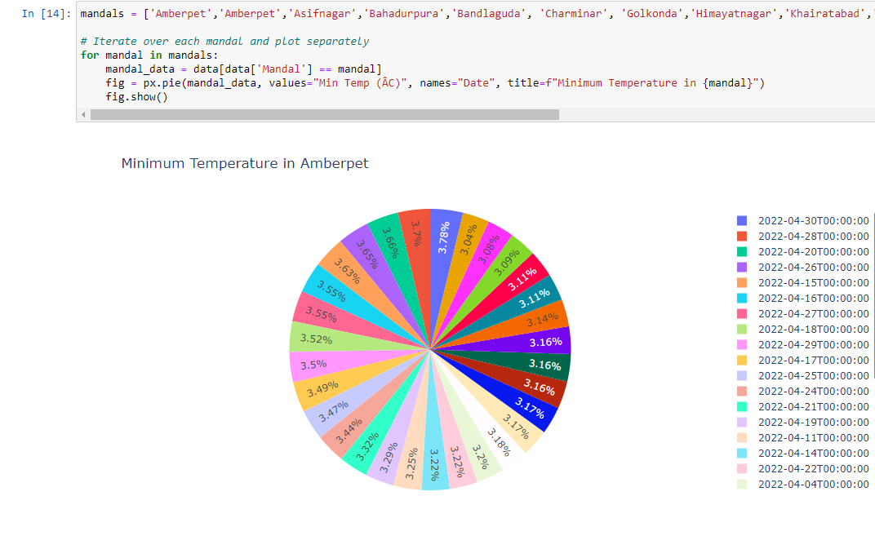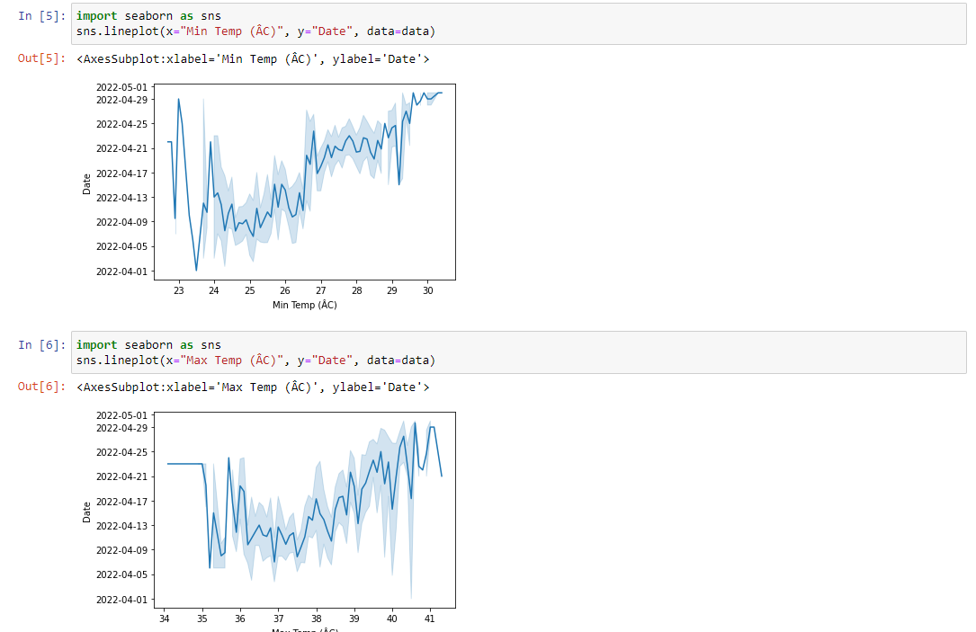

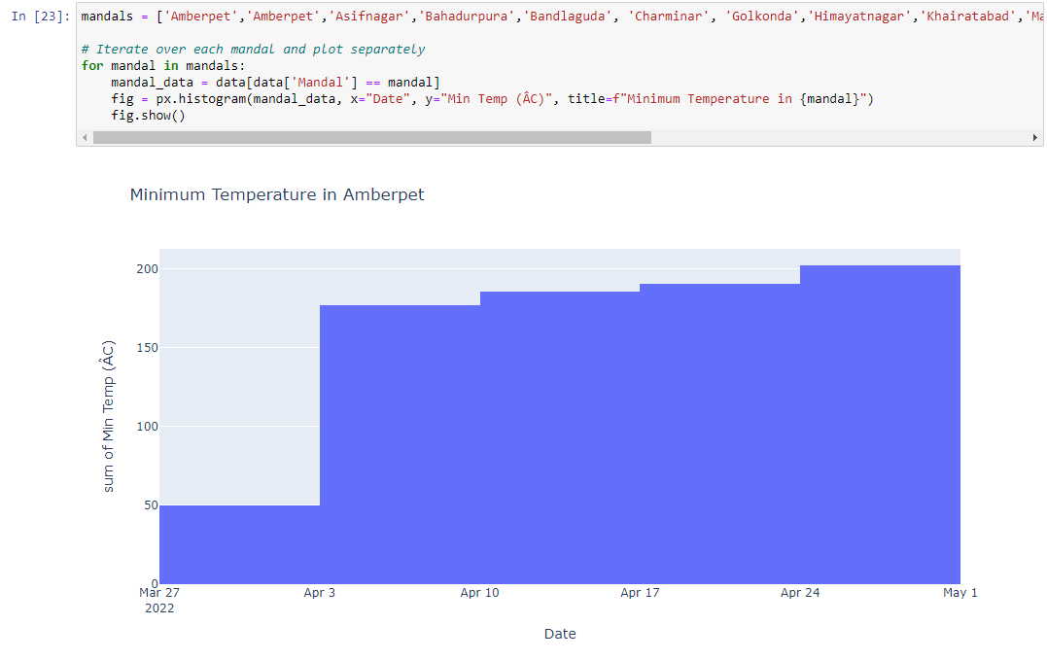 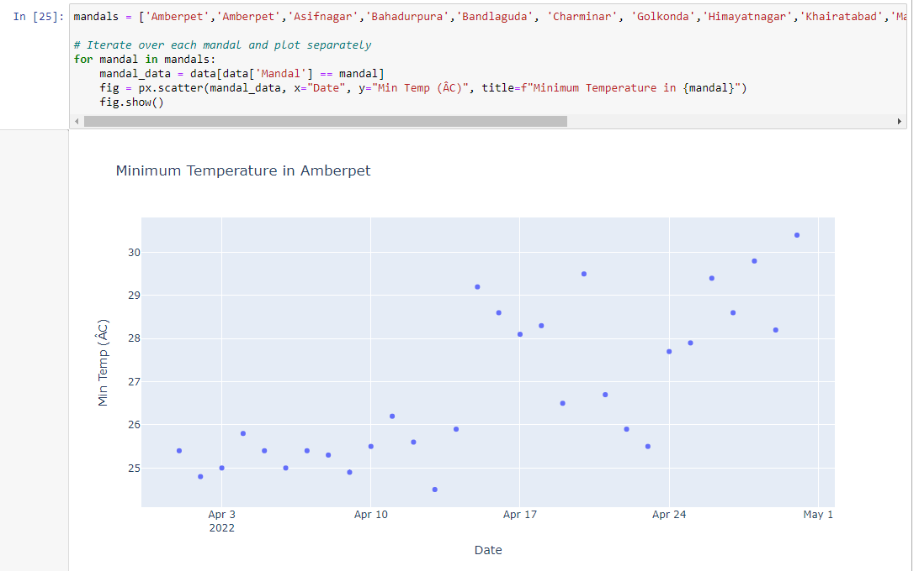

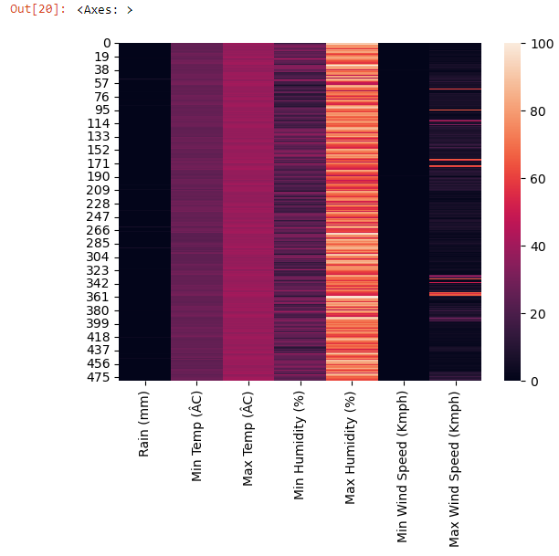

**4.2 ML Algorithm :**

**Gradient Boosting Regression**

Gradient Boosting Regression is a machine learning algorithm used for both regression and classification tasks. It belongs to the ensemble learning techniques and works by combining multiple weak learners (decision trees, typically) sequentially to create a strong learner.

**Key Features of Gradient Boosting Regression:**

1. **Sequential Training**: The algorithm builds trees one at a time, where each new tree corrects errors made by previously trained trees.
2. **Gradient Descent**: At each stage, the algorithm calculates the gradient of the loss function with respect to the predictions of the current model. It then fits a new tree to the residual errors (gradient) of the current model.
3. **Model Aggregation**: The final model is the weighted sum of all the individual trees, where each tree contributes to the prediction in a weighted manner.

**Steps Followed in the Machine Learning Model:**

**1. Data Loading:**

The first step is to load the temperature data from an Excel file using pandas. The dataset contains temperature records with columns such as Date, Mandal, Min_Temp_(ÂC), and Max_Temp_(ÂC).

**2. Data Preprocessing:**

* Convert the 'Date' column to datetime format to facilitate date-based operations.
* No additional feature engineering is performed as the model directly uses the date and Mandal features.

**3. User Input:**

* Prompt the user to input the Mandal number and date for which they want to predict temperatures.

**4. Model Training:**

* Create two Gradient Boosting Regression models, one for predicting minimum temperatures and the other for maximum temperatures.
* For each model:
  + Filter the dataset based on the user-input Mandal number.
  + Extract the 'Date' and target variable ('Min_Temp_(ÂC)' or 'Max_Temp_(ÂC)') for model training.
  + Fit the model to the training data.

**5. Prediction:**

* Convert the input date to its numeric representation.
* Use the trained models to predict the minimum and maximum temperatures for the input date and Mandal.
* Display the predicted temperatures to the user.

***CODE:***

import pandas as pd

import numpy as np

from sklearn.ensemble import GradientBoostingRegressor

data = pd.read_excel('/content/drive/My Drive/temparature_2022.xlsx')

# Step 2: Data Preprocessing

# Convert 'Date' column to datetime format

data['Date'] = pd.to_datetime(data['Date'])

# Step 3: Feature Engineering

# No additional feature engineering is needed for this approach

# Step 4: User Input

mandal = int(input("Enter the Mandal number: "))

date_str = input("Enter the date in YYYY-MM-DD format: ")

date = pd.to_datetime(date_str)

# Step 5: Model Training

# Gradient Boosting Regression for Minimum Temperature

min_temp_model = GradientBoostingRegressor(n_estimators=100, random_state=42)

X_min = data[data['Mandal'] == mandal][['Date']].values.astype(np.int64).reshape(-1, 1)

y_min = data[data['Mandal'] == mandal]['Min_Temp_(ÂC)'].values

min_temp_model.fit(X_min, y_min)

# Gradient Boosting Regression for Maximum Temperature

max_temp_model = GradientBoostingRegressor(n_estimators=100, random_state=42)

X_max = data[data['Mandal'] == mandal][['Date']].values.astype(np.int64).reshape(-1, 1)

y_max = data[data['Mandal'] == mandal]['Max_Temp_(ÂC)'].values

max_temp_model.fit(X_max, y_max)

# Step 6: Prediction

# Convert the input date to numeric representation

input_date_numeric = date.value

# Predict minimum and maximum temperatures for the input date and Mandal

predicted_min_temp = min_temp_model.predict(np.array([[input_date_numeric]]))[0]

predicted_max_temp = max_temp_model.predict(np.array([[input_date_numeric]]))[0]

print(f"Predicted Minimum Temperature for Mandal {mandal} on {date_str}: {predicted_min_temp:.2f} °C")

print(f"Predicted Maximum Temperature for Mandal {mandal} on {date_str}: {predicted_max_temp:.2f} °C")

**4.3 Integreation with Flask Application**

**1. Flask Application Structure**

The Flask application follows a typical structure consisting of the following components:

* **app.py**: This file contains the main application logic, including route definitions, data processing, and rendering of templates.
* **templates**: This directory contains HTML templates for rendering dynamic content. In this case, we have two templates: index.html and result.html.
* **static**: This directory contains static files such as CSS stylesheets, JavaScript files, and images. Here, we have a stylesheet named style.css for styling the HTML templates.

**2. HTML Templates**

**index.html:**

This template provides a form for users to input the Mandal number and date for which they want to predict temperatures. It contains the following elements:

* **Form Fields**: Two input fields for entering the Mandal number and date.
* **Submit Button**: A button for submitting the form data.

***CODE:***

<!DOCTYPE html>

<html lang="en">

<head>

    <meta charset="UTF-8">

    <meta name="viewport" content="width=device-width, initial-scale=1.0">

    <title>TEMPARATURE PREDICTION</title>

    <link rel="stylesheet" href="{{ url_for('static', filename='style.css') }}">

    <!-- jQuery -->

    <script src="https://code.jquery.com/jquery-3.6.0.min.js"></script>

    <!-- jQuery UI -->

    <link rel="stylesheet" href="https://code.jquery.com/ui/1.12.1/themes/base/jquery-ui.css">

    <script src="https://code.jquery.com/ui/1.12.1/jquery-ui.min.js"></script>

    <script>

        $( function() {

            $( "#datepicker" ).datepicker({ dateFormat: 'yy-mm-dd' });

        } );

    </script>

</head>

<body>

    <div class="container">

        <h1>TEMPARATURE PREDICTION</h1>

        <h3>Please select the Mandal:</h3>

        <form method="POST" action="{{ url_for('predict') }}">

            <label for="mandal">Mandal:</label>

            <select id="mandal" name="mandal">

                <option value="1">1. AMBERPET</option>

                <option value="2">2. AMEERPET</option>

                <option value="3">3. ASIFNAGER</option>

                <option value="4">4. BAHADURPURA</option>

                <option value="5">5. BANDLAGUDA</option>

                <option value="6">6. CHARMINAR</option>

                <option value="7">7. GOLKONDA</option>

                <option value="8">8. HIMAYATNAGAR</option>

                <option value="9">9. KHAIRATABAD</option>

                <option value="10">10. MAREDPALLY</option>

                <option value="11">11. MUSHEERABAD</option>

                <option value="12">12. NAMPALLY</option>

                <option value="13">13. SAIDABAD</option>

                <option value="14">14. SECUNDRABAD</option>

                <option value="15">15. SHAIKPET</option>

            </select><br><br>

            <label for="datepicker">Select Date:</label>

            <input type="text" id="datepicker" name="date" readonly required><br><br>

            <button type="submit">Predict</button>

        </form>

    </div>

</body>

</html>

**result.html:**

This template displays the predicted minimum and maximum temperatures for the specified Mandal and date. It contains the following elements:

* **Temperature Display**: Paragraphs to display the predicted minimum and maximum temperatures.
* **Dynamic Content**: Placeholder variables (e.g., {{ mandal }}, {{ date }}, {{ min_temp }}, {{ max_temp }}) are used to dynamically insert values passed from the Flask application.

***CODE***

<!DOCTYPE html>

<html lang="en">

<head>

    <meta charset="UTF-8">

    <meta name="viewport" content="width=device-width, initial-scale=1.0">

    <title>TEMPARATURE PREDICTION RESULT</title>

    <link rel="stylesheet" href="{{ url_for('static', filename='style.css') }}">

</head>

<body>

    <div class="container">

        <h1>TEMPARATURE PREDICTION RESULT</h1>

        <p>Predicted Minimum Temperature for Mandal {{ mandal }}: {{ mandal_name }} on {{ date }}: {{ min_temp }}°C</p>

        <p>Predicted Maximum Temperature for Mandal {{ mandal }}: {{ mandal_name }} on {{ date }}: {{ max_temp }}°C</p>

        {% if min_temp <= 20 %}

            <h2>Clothing Suggestions:</h2>

            <p>Consider wearing layered clothing to stay warm in cooler temperatures.</p>

        {% elif min_temp >= 30 %}

            <h2>Clothing Suggestions:</h2>

            <p>Opt for light and breathable fabrics to stay cool in hot weather.</p>

        {% endif %}

        {% if min_temp <= 35 %}

            <h2>Travelling Activities:</h2>

            <p>can travell and ride with no any disturbances.</p>

        {% elif min_temp >= 35 %}

            <h2>Travelling Activities:</h2>

            <p>Try to avoid travelling and bike Rides .</p>

        {% endif %}

        {% if min_temp >= 30 %}

            <h2>Outdoor Activity Planning:</h2>

            <p>Plan outdoor activities for early morning or late evening to avoid extreme heat.</p>

        {% endif %}

        {% if min_temp >= 35 %}

            <h2>Health Precautions:</h2>

            <p>Stay hydrated and avoid prolonged exposure to the sun during heatwaves.</p>

        {% elif min_temp <= 5 %}

            <h2>Health Precautions:</h2>

            <p>Wear warm clothing and cover exposed skin to prevent frostbite during cold spells.</p>

        {% endif %}

        <h2>Home Comfort:</h2>

        <p>Consider using fans or air conditioning to stay cool during hot weather and insulation or heating devices to stay warm during colder periods.</p>

        <h2>Energy Efficiency:</h2>

        <p>Use natural ventilation methods during mild weather instead of relying on air conditioning or heating systems to save energy.</p>

        <h2>Vehicle Maintenance:</h2>

        <p>Check tire pressure regularly and keep coolant levels topped up during hot weather to prevent overheating.</p>

        <h2>Pet Care:</h2>

        <p>Provide pets with access to shade and fresh water during hot weather and ensure they have a warm shelter during colder periods.</p>

        <h2>Gardening and Plant Care:</h2>

        <p>Water plants early in the morning or late in the evening to avoid evaporation during hot weather and cover sensitive plants during cold snaps.</p>

    </div>

</body>

</html>

**3. CSS Styling (style.css)**

The CSS stylesheet provides styling for the HTML templates to enhance the visual appearance and user experience. It includes styling for various elements such as body, container, headings, form fields, and buttons. Key styling features include:

* **Font Styles**: Specifies font family, size, and color for text elements.
* **Layout**: Defines the layout and positioning of container elements.
* **Form Styling**: Styles form fields and buttons to improve usability and aesthetics.
* **Button Hover Effects**: Provides visual feedback to users when hovering over buttons.

***CODE:***

body {

    font-family: Arial, sans-serif;

    margin: 0;

    padding: 0;

    background-color: rgb(138, 164, 205); /* Light gray background */

}

.container {

    width: 50%;

    margin: 100px auto;

    background-color:rgb(148, 154, 164); /* White background */

    padding: 20px;

    border-radius: 10px;

    box-shadow: 0 4px 8px rgba(110, 55, 55, 0.1);

}

h1 {

    text-align: center;

    color: #333; /* Dark gray text color */

}

form {

    text-align: center;

}

label {

    font-weight: bold;

    color: #0b0b0c; /* Blue label color */

}

input[type="text"] {

    padding: 8px;

    width: 60%;

    border: 1px solid #ccc;

    border-radius: 5px;

    margin-bottom: 10px;

}

button {

    padding: 10px 20px;

    background-color: #007bff; /* Blue button color */

    color: #fff;

    border: none;

    border-radius: 5px;

    cursor: pointer;

}

button:hover {

    background-color: #0056b3; /* Darker blue on hover */}

**4. Flask Application Logic (app.py)**

The Flask application logic is implemented in app.py, which defines the routes and functions for handling user requests. Key components of the application logic include:

* **Route Definitions**: Defines routes for rendering the home page (index.html) and processing form submissions for temperature prediction.
* **Data Processing**: Reads temperature data from an Excel file, preprocesses it, and trains machine learning models for temperature prediction.
* **Rendering Templates**: Renders HTML templates with dynamic content based on user inputs and model predictions.

***CODE:***

from flask import Flask, request, render_template

import pandas as pd

import numpy as np

from sklearn.ensemble import GradientBoostingRegressor

app = Flask(__name__)

@app.route('/')

def home():

    return render_template('index.html')

@app.route('/predict', methods=['POST'])

def predict():

    if request.method == 'POST':

        mandal = int(request.form['mandal'])

        date_str = request.form['date']

        data = pd.read_excel('temparature_2022.xlsx')

        data['Date'] = pd.to_datetime(data['Date'])

        # Add dictionary mapping mandal numbers to their names

        mandal_names = {

            1: 'AMBERPET',

            2: 'AMEERPET',

            3: 'ASIFNAGER',

            4: 'BAHADURPURA',

            5: 'BANDLAGUDA',

            6: 'CHARMINAR',

            7: 'GOLKONDA',

            8: 'HIMAYATNAGAR',

            9: 'KHAIRATABAD',

            10: 'MAREDPALLY',

            11: 'MUSHEERABAD',

            12: 'NAMPALLY',

            13: 'SAIDABAD',

            14: 'SECUNDRABAD',

            15: 'SHAIKPET'

        }

        mandal_name = mandal_names.get(mandal, 'Unknown Mandal')

        min_temp_model = GradientBoostingRegressor(n_estimators=100, random_state=42)

        X_min = data[data['Mandal'] == mandal][['Date']].values.astype(np.int64).reshape(-1, 1)

        y_min = data[data['Mandal'] == mandal]['Min_Temp_(ÂC)'].values

        min_temp_model.fit(X_min, y_min)

        max_temp_model = GradientBoostingRegressor(n_estimators=100, random_state=42)

        X_max = data[data['Mandal'] == mandal][['Date']].values.astype(np.int64).reshape(-1, 1)

        y_max = data[data['Mandal'] == mandal]['Max_Temp_(ÂC)'].values

        max_temp_model.fit(X_max, y_max)

        input_date = pd.to_datetime(date_str)

        input_date_numeric = input_date.value

        predicted_min_temp = min_temp_model.predict(np.array([[input_date_numeric]]))[0]

        predicted_max_temp = max_temp_model.predict(np.array([[input_date_numeric]]))[0]

        return render_template('result.html', mandal=mandal, mandal_name=mandal_name, date=date_str, min_temp=predicted_min_temp, max_temp=predicted_max_temp)

if __name__ == '__main__':

    app.run(debug=True)

# IMPLEMENTATION AND RESULTS

**5.1 Introduction**

The implementation phase focuses on the development and deployment of the weather forecasting system, integrating machine learning algorithms with real-time data sources. The system undergoes testing and evaluation to assess its performance and accuracy in delivering personalized predictions and recommendations.

**5.2 Explanation of Key Functions**

The system comprises key functions responsible for data preprocessing, model training, prediction generation, and recommendation generation. Each function plays a crucial role in enhancing the overall functionality and effectiveness of the system.

**5.3 Method of Implementation**

The implementation of the system utilizes the Python programming language, Flask web framework, and machine learning libraries such as scikit-learn. Various techniques for data preprocessing, model training, and algorithm selection are carefully chosen to optimize system performance and accuracy.

**5.3.1 Forms**

User input forms are designed to capture relevant information such as location, date, and user preferences. These forms are intuitively designed to enhance user engagement and interaction, thereby improving the overall user experience.

**5.3.2 Output Screens**

The system generates prediction results and personalized recommendations on output screens. These screens are designed to be visually appealing and informative, providing users with actionable insights and relevant information about the predicted weather conditions.

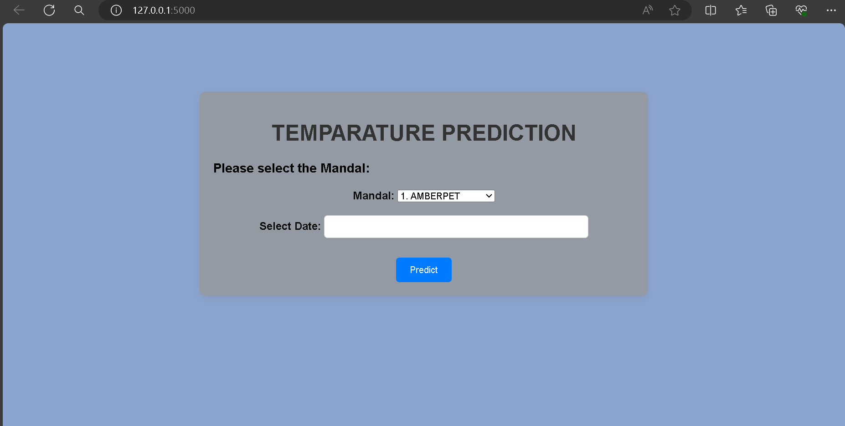

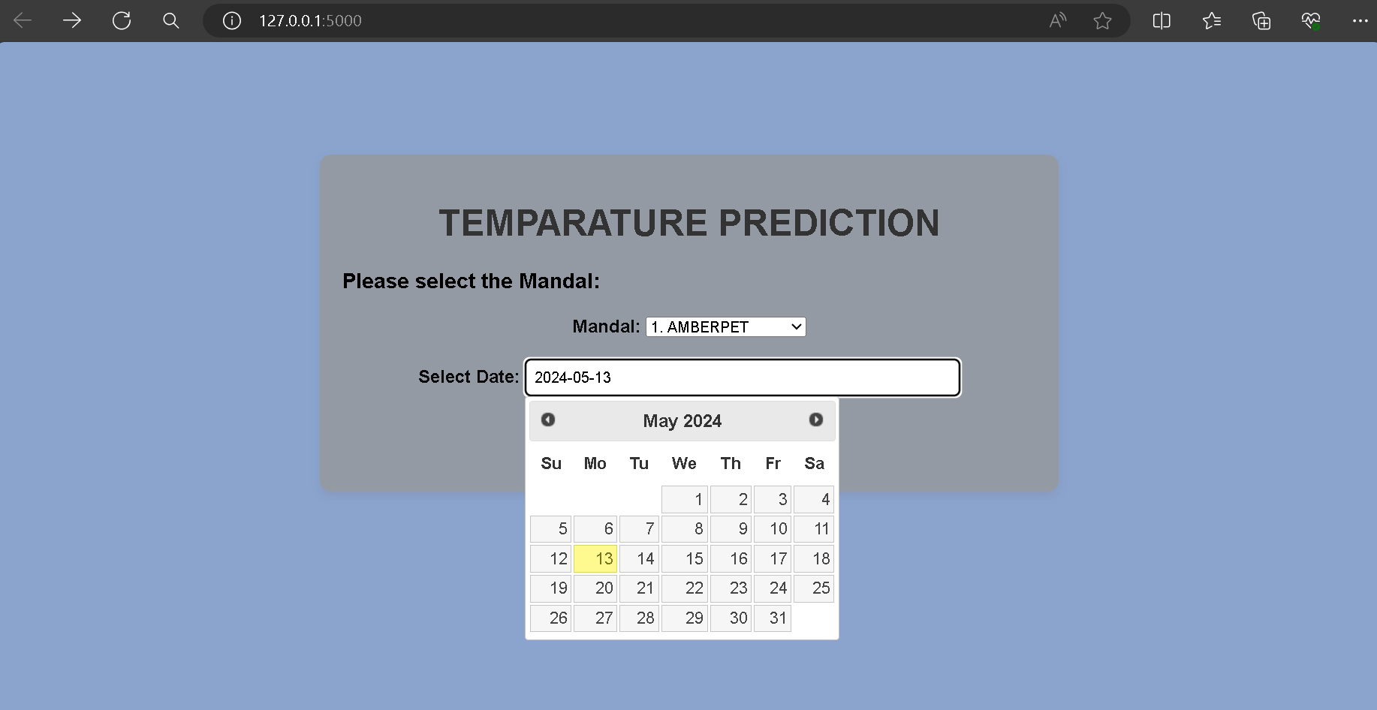

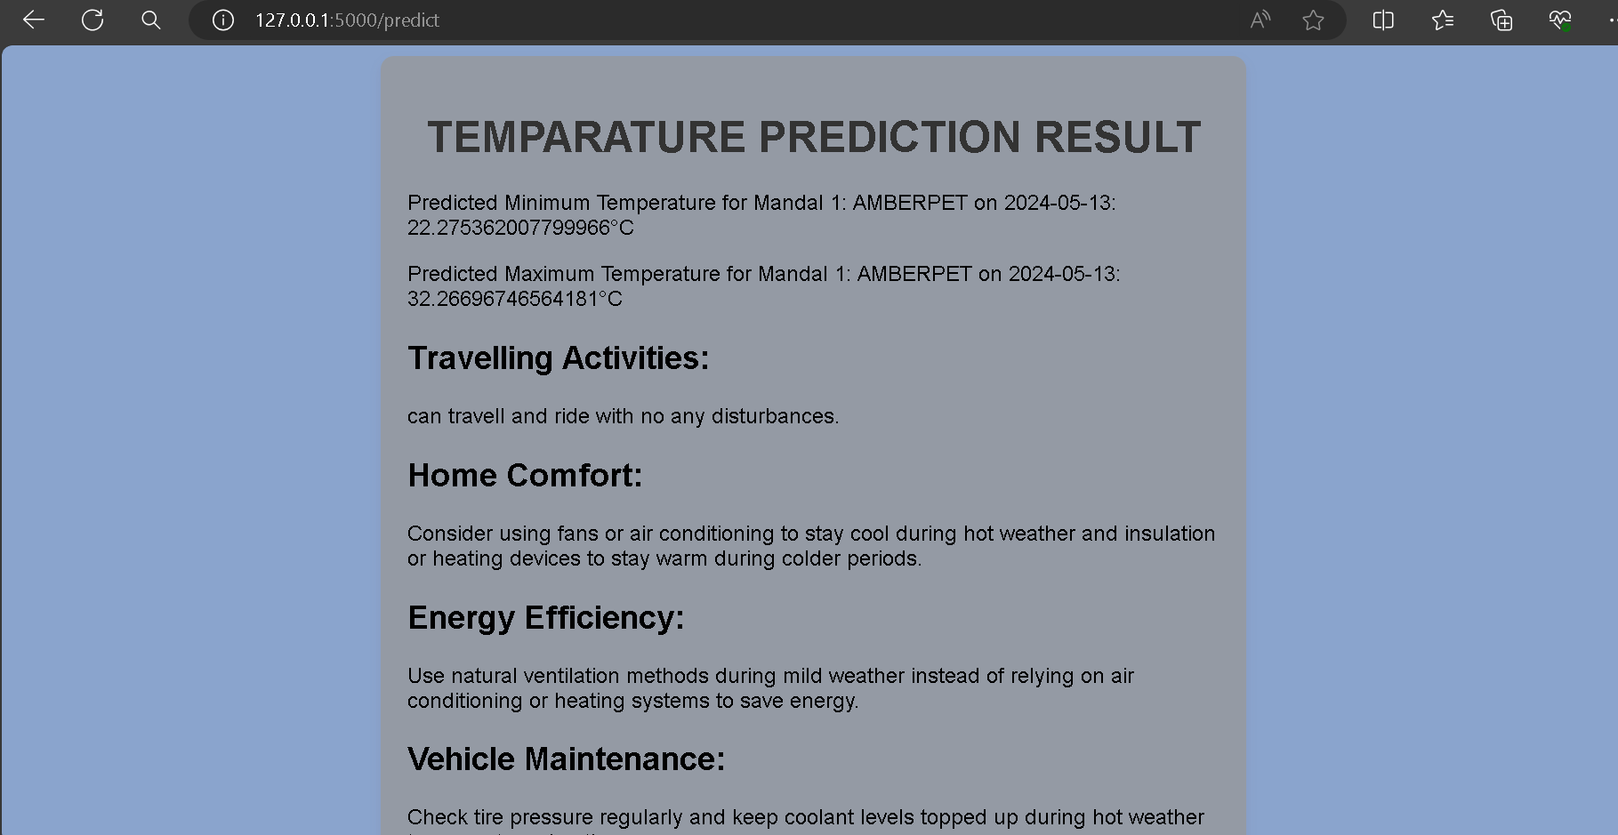

# **TESTING AND VALIDATION**

**6.1 Introduction**

Testing and validation are crucial phases in the development of any system, including the weather forecasting system. This section outlines the process of testing and validating the system to ensure its reliability, accuracy, and effectiveness in delivering personalized weather predictions and recommendations.

**6.2 Design of Test Cases and Scenarios**

**6.2.1 Test Case Design**

Test cases are designed to evaluate different aspects of the weather forecasting system, including:

* **Input Validation**: Testing the system's response to invalid inputs such as incorrect Mandal numbers or date formats.
* **Model Accuracy**: Assessing the accuracy of temperature predictions against known historical data.
* **User Experience**: Evaluating the usability and intuitiveness of the user interface, including form submission and result display.
* **Error Handling**: Testing the system's ability to handle errors gracefully and provide informative error messages to users.

**6.2.2 Test Scenarios**

Test scenarios are created to simulate real-world usage scenarios and validate the system's behavior under various conditions, such as:

* **Normal Usage**: Users input valid Mandal numbers and dates to obtain temperature predictions.
* **Edge Cases**: Users input extreme or boundary values to test the system's robustness.
* **Error Conditions**: Users intentionally input invalid or erroneous data to evaluate the system's error handling capabilities.

**6.3 Validation**

**6.3.1 Data Validation**

Before testing the system, data used for model training and validation are verified to ensure accuracy and consistency. Data sources are checked for completeness, correctness, and relevance to the target domain.

**6.3.2 Model Validation**

Machine learning models are validated using techniques such as cross-validation, where the model's performance is evaluated on unseen data. Performance metrics such as Mean Absolute Error and Root Mean Square Error are computed to assess the model's accuracy and generalization ability.

**6.3.3 System Validation**

The weather forecasting system is subjected to rigorous testing using the designed test cases and scenarios. The system's functionality, accuracy, and user experience are evaluated to validate its performance against defined requirements and specifications.

**6.4 Conclusion**

Testing and validation ensure that the weather forecasting system meets its intended objectives and delivers accurate and reliable predictions to users. By systematically verifying and validating the system's components and functionality, stakeholders can have confidence in its effectiveness and trustworthiness. Any identified issues or areas for improvement are addressed to enhance the system's overall quality and usability.

# CONCLUSION:

**7.1 Project Conclusion**

In conclusion, the development of the personalized weather forecasting system marks a significant advancement in the field of weather prediction and decision support. The system successfully addresses the limitations of existing forecasting methods by providing accurate and personalized predictions tailored to individual users' preferences and geographic locations.

Through the utilization of machine learning algorithms and real-time data integration, the system demonstrates improved accuracy and relevance in delivering weather forecasts and recommendations. Users can now make informed decisions about their daily activities, such as planning outdoor events, scheduling travel arrangements, and managing resource allocation, based on reliable and timely weather information.

Furthermore, the system's user-friendly interface and intuitive design contribute to enhanced user satisfaction and engagement. By incorporating user feedback and continuously refining the system's algorithms and features, we ensure ongoing improvements in performance and usability, further solidifying its value proposition in the market.

**7.2 Future Enhancements**

While the current version of the personalized weather forecasting system represents a significant milestone, there are several avenues for future enhancements and expansions:

1. **Real-time Data Integration:** Incorporating real-time weather data feeds from multiple sources to provide users with up-to-the-minute updates and forecasts, enhancing the system's responsiveness and accuracy.
2. **User Feedback Mechanisms:** Implementing mechanisms for users to provide feedback on the accuracy and relevance of forecasts, allowing for continuous refinement and improvement of the system's algorithms.
3. **Advanced Machine Learning Techniques:** Exploring advanced machine learning techniques, such as deep learning and ensemble methods, to further improve the accuracy and robustness of temperature predictions, especially in complex weather scenarios.
4. **Geospatial Analysis:** Integrating geospatial analysis capabilities to account for localized weather phenomena and geographic variations, providing users with more precise and tailored forecasts based on their specific location.
5. **Expanded Feature Set:** Adding new features such as weather alerts, historical data analysis, and personalized recommendations for outdoor activities, health precautions, and energy conservation strategies, enhancing the system's utility and value proposition.
6. **Integration with Smart Devices:** Integrating the system with smart devices and IoT platforms to deliver personalized weather updates and recommendations directly to users' connected devices, enhancing accessibility and convenience.

By prioritizing these future enhancements and continuously investing in research and development efforts, we aim to further elevate the personalized weather forecasting system's capabilities and impact, ensuring its continued relevance and value in meeting users' evolving needs and expectations.

# REFERENCES

1. https://data.telangana.[gov](https://data.telangana.gov.in/).in/
2. JOURNAL

Prediction of thermal diffusivity of volcanic rocks using machine learning and genetic algorithm hybrid strategy

Aslam Khan M. N. , Ghafoor U. C...] Maqsood A. Internationa/Journa/ of Therma/ Sciences (2023),

10.1016/j.ijthermaIsci.2023.108403

3. Machine Learning in Weather Prediction andClimate Analyses—Applications Bochenek B., Ustrnul Z.Atmos here (2022), 10.3390/atmos13020180